Warm-ups

Exercise 1B: The Pure Number Filter
Your Goal: Write a program or function that takes a list of numbers and does two things:
- Filters out any numbers that are less than 10.
- Returns a new list containing only the remaining numbers exactly as they are (without changing their values).
Example:
- Input list: [3, 12, 5, 20, 8, 15]
- Expected output: [12, 20, 15] (Since 12, 20, and 15 are ≥ 10, they are kept in the list exactly as they are)

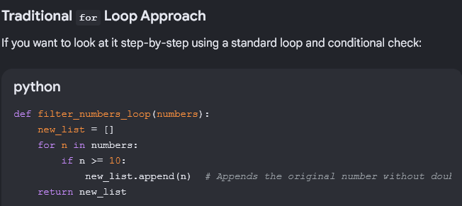

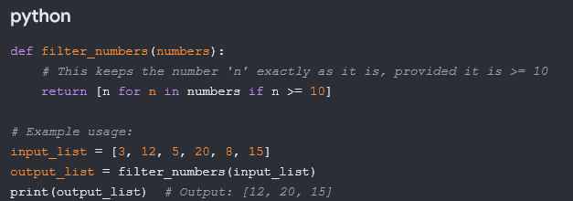
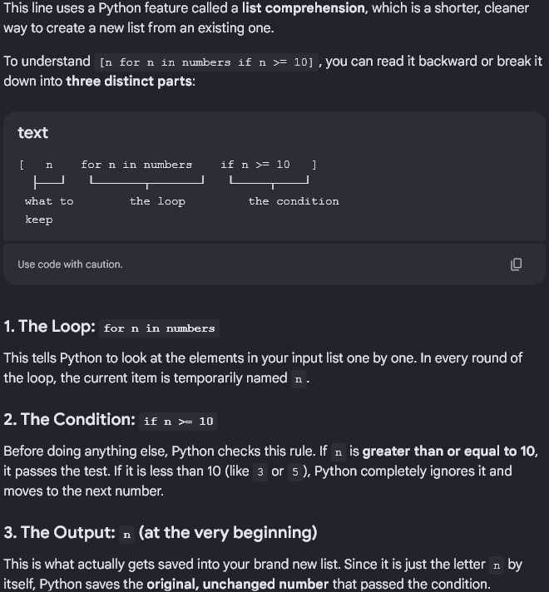

Exercise 1B: The Number Filter
Your Goal: Write a program or function that takes a list of numbers and does two things:
- Filters out any numbers that are less than 10.
- Returns a new list containing only the remaining numbers, but doubled.
Example:
- Input list: [3, 12, 5, 20, 8, 15]
- Expected output: [24, 40, 30] (Since 12, 20, and 15 are ≥ 10, and their values are doubled)

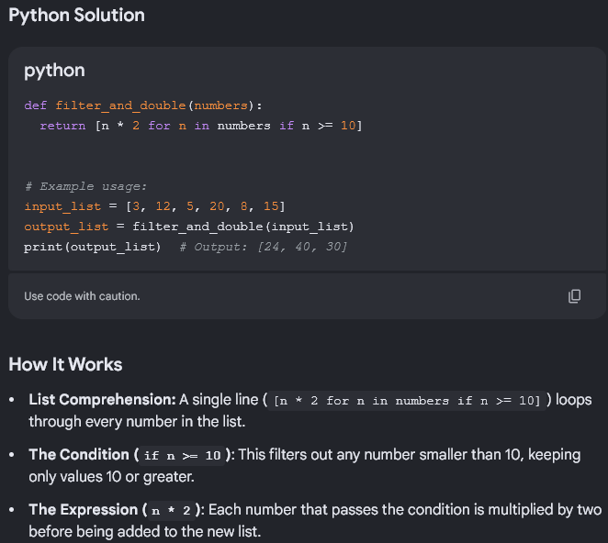

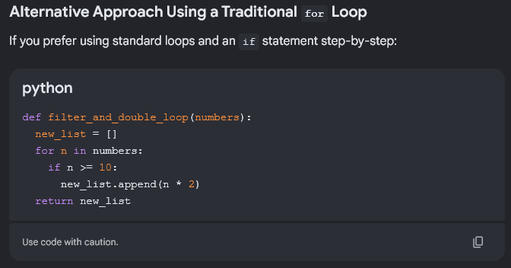
You Can also use Python's built-in filter() and map() functions instead.

Exercise 2A
Your Goal: Write a program that takes a string and counts how many times each letter appears.
- Input string: "apple"
- Expected output dictionary: {'a': 1, 'p': 2, 'l': 1, 'e': 1}
How would you approach counting the characters?

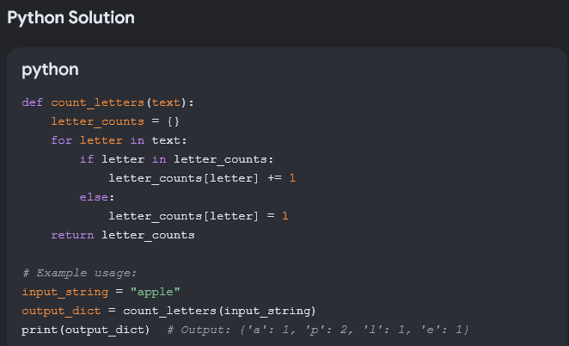

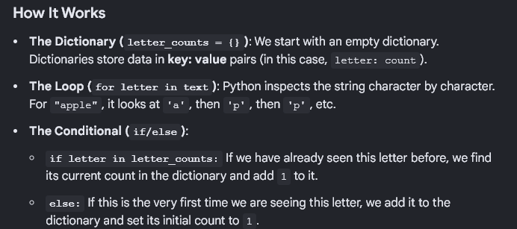
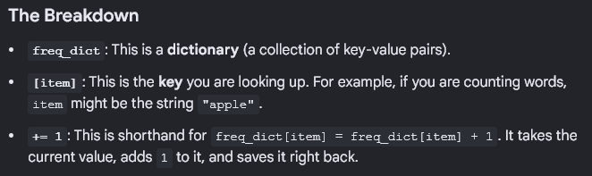
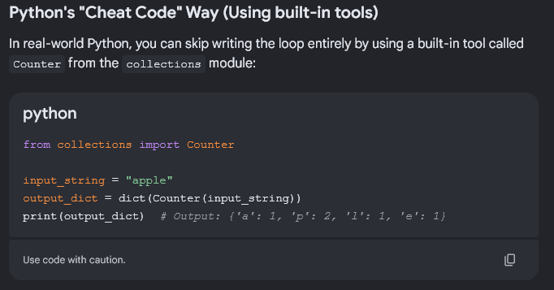

Exercise 2B: The Detailed Character Counter
Your Goal: Write a program that counts how many times each letter appears in a given string, and then prints out a personalized summary sentence for each unique letter found.
Requirements:
- Create a function that processes a string and returns a dictionary tracking character frequencies.
- Iterate through the resulting dictionary to display a formatted message for each letter exactly like the format below.
Example:
- Input string: "apple"
- Expected Console Output

